Big 0 video 1

At a simple level how could we classify the complexity of the two algorithms?

Which of the two algorithms is better?

Why?

What happens when you try and scale up the number of names entered on the two piece of code?

1:54 in what does the complexity = 3+3n+1 actually mean?

What are the two key measures of an algorithm's complexity

3:22 in is there a better way of simplifying the above representation of the complexity of the algorithm?

3:53 in how do you determine which bit of the equation is the most significant part

4:27 what are the two simple rules of Big O

4:59 taking the simplified equation from earlier what does the Big O notation of this formula look like?

5:27 What do we mean by linear complexity?

5:50 recap so far......

The big O complexity gradient...

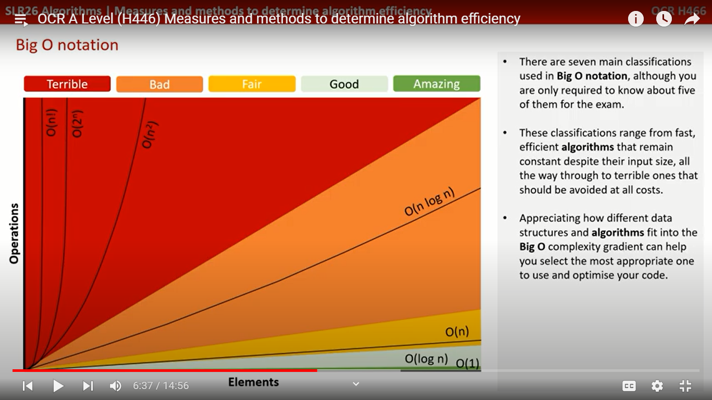

6:51 write down each of the notations, the name and description

|  |  |  |
| --- | --- | --- |
| Notation | Name | Description |
|  |  |  |
|  |  |  |
|  |  |  |
|  |  |  |
|  |  |  |
|  |  |  |
|  |  |  |

7:15 with constant complexity ….....execution time …......

What happens with constant complexity regardless of the size of the data set

7:25 What happens with a logarithmic complexity …

Give one example of an algorithm that has logarithmic complexity....

8:03 What happens / characterizes linear complexity

8:26 describe the polynomial complexity and what characterizes this type of complexity

What is another name for polynomial complexity

Give two common examples of algorithms that have polynomial complexity

Looking at the code what trait can you pick out to help spot this type of complexity

9:32 define exponential complexity and give an example

10:52 multiple functions being performed … what happens when each time complexity is assessed

How was this achieved ?

12:27 write down the quick tips and hints on how for working out Big O Complexity

Big O video 2 Comparing the complexity of algorithms

1:27 what complexity is given to adding data to the end of an array

2:03 what time complexity is given to searching for a barcode in an unordered list

2:42 Assuming best case scenario what time complexity would the search algorithms have?

3:11 referring to the table provided and the notes you made earlier from the previous video write down the average and worst case scenarios for each of the algorithms. Might be worth using the notation as well as the names from the previous video

Which has the worst, worst case scenario performance

Which has the best average case performance

4:11 how does the algorithm compare if you try and insert an item whilst trying to maintain the data in a serial order

4:27 what advantage does having a sorted list provide ? What level of complexity does it provide. Which search algorithm does this best describe.

5:36 pushing and popping from stacks and queues have which time complexity?

6:14 searching for an item in a stack / queue has which time complexity ? Why?

6:30 Hash tables what time complexity does it have and why?

6:49 what time complexity do overflow tables have ?

7:31 Linked lists what time complexity does it have and why?

8:06 what time complexity is given to adding and deleting items from a linked list?

8:25 Binary search trees what time complexity does it have and why?

8:44 traversing an entire binary tree what time complexity does it have and why?

9:05 bubble sort what time complexity does it have and why?

9:05 insertion sort what time complexity does it have and why?

9:49 Comparing sorting algorithms

10:53 What do you need to know for the exam

Start to compile a summary that easy allows you easily compare and contrast them

**Big O video 3 Big O in practice**

0:44 How is Big O used in video games?

1:17 how does this work?

1:40 if there is 1 missile and 1 alien then which complexity is this ?

1:45 if there are multiple aliens and what level of complexity is this? Wha data structure would be used with detecting collision of one missile and several aliens

2:22 Now we have multiple missiles and multiple aliens what coding technique would be used to check through all these items? What complexity does this fit into?

3:34 by adding multiple missiles and multiple aliens what problems does this cause?

4:20 How can they be solved

5:12 what would this solution look like in terms of coding?

5:50 what issues does this particular strategy suffer from ?